**How to setup a QNX VM to bridge**

One of the QNX VM network adapters need to be set to bridge connection in order to communicate with a UUT. To set one up, we need to use the Virtual Network Editor in Admin mode.

1. Open the Virtual Network Editor 
2. Change to Admin mode 
3. Add a new Network 
4. One the new Network is added it can be renamed to a more relevant name (i.e. QNX Bridge)  
   
5. Set the new network to Bridge and make sure to pick the correct Network Adapter you will physically connect to:  
   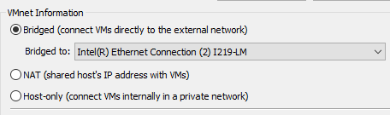
6. You can find the name of the Adapters by looking at the Windows Network configuration (Control Panel\Network and Internet\Network Connections)  
   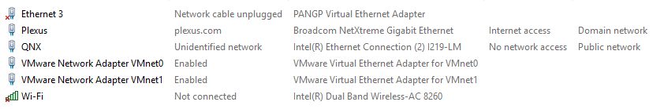
7. ON the QNX VM setting, change the Netowrk adapter you want to used and connect it to the new adapter defined in step 5  
   